**<g3>**

***Mark the letter $A,B,C$, or $D$ on your answer sheet to indicate the word whose underlined part differs from that of the other three in pronunciation in each of the following questions.***

**Question 1.**

**A.** face

**B.** take

**C.** fan

**D.** make

**Question 2.**

**A.** routine

**B.** talent

**C.** tourist

**D.** patient

**<g3>**

***Mark the letter $A,B,C$, or $D$ on your answer sheet to indicate the word that differs from the other three in the position of stress in each of the following questions.***

**Question 3.**

**A.** common

**B.** profit

**C.** attract

**D.** travel

**Question 4.**

**A.** discussion

**B.** gratitude

**C.** celebrate

**D.** opposite

**<g3>**

***Mark the letter $A,B,C$, or $D$ on your answer sheet to indicate the correct answer to each of the following questions.***

**Question 5.** Human life expectancy greatly in the past few decades since scientists identifed the genes responsible for disease resistance.

**A.** increases

**B.** has increased

**C.** increase

**D.** is increasing

**Question 6.** They had to bring in an outside specialist to install the computer system, ?

**A.** hadn't they

**B.** weren't they

**C.** didn't they

**D.** haven't they

**Question 7.** It is obvious that a baby elephant is than a lion cub.

**A.** heavier

**B.** heavy

**C.** heaviest

**D.** more heavier

**Question 8.** The pressure cooker is designed to allow faster at lower temperatures.

**A.** to cook

**B.** to cooking

**C.** cook

**D.** cooking

**Question 9.** Increasing temperatures worldwide due to global warming has a reduction in sales of tea in the UK recently.

**A.** brought about

**B.** taken after

**C.** put forward

**D.** turned up

**<g2>**

***Read the following advertisement/school announcement and mark the letter $A,B,C$, or $D$ on your answer sheet to indicate the correct option that best fits each of the numbered blanks from 10 to 15.***

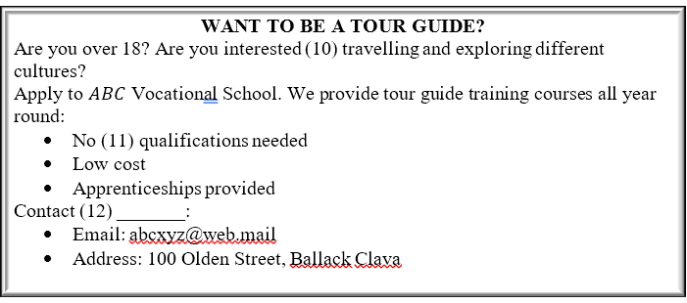

**Question 10.**

**A.** in

**B.** on

**C.** at

**D.** for

**Question 11.**

**A.** a

**B.** an

**C.** the

**D. $∅$**  (no article)

**Question 12.**

**A.** information

**B.** inform

**C.** informative

**D.** informatively

**<g2>**

**Question 13.**

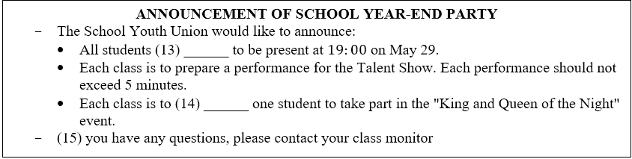

**A.** are required

**B.** requiring

**C.** requires

**D.** have required

**Question 14.**

**A.** nominate

**B.** dominate

**C.** activate

**D.** illustrate

**Question 15.**

**A.** Should

**B.** Had

**C.** Were

**D.** Do

**<g2>**

***Mark the letter $A,B,C$, or $D$ on your answer sheet to indicate the correct arrangement of the sentences to make a meaningful paragraph/letter in each of the following questions.***

**Question 16.** a. Also, volunteering helps students connect with the community, making them aware of the needs around them.

b. Additionally, students develop such important skills as teamwork and communication ones while they volunteer.

c. Firstly, students who do voluntary work gain valuable real-world experience which can help in their future careers. d. Finally, doing volunteer work can be a rewarding experience, as students feel good about helping others. e. High school students benefit from doing voluntary work in many ways.

**A. $e-c-a-b-d$**

**B. $e-a-c-b-d$**

**C. $c-a-b-d-e$**

**D. $c-e-a-b-d$**

**Question 17.** a. Besides, doing chores together can actually be fun and it makes the work go faster.

b. Dear Mike, I hope you are well! I've been thinking about why it's important for children to help with housework.

c. It's a good way for families to spend time together and learn new skills.

d. Firstly, it teaches us responsibility and how to take care of our own things.

e. Also, when we help our parents, it shows them respect and gratitude for all they do for us.

f. Best wishes.

**A. $b-c-a-e-d-f$**

**B. $b-d-e-a-c-f$**

**C. $b-a-d-e-c-f$**

**D. $b-e-d-a-c-f$**

**<g2>**

***Mark the letter $A,B,C$, or $D$ on your answer sheet to indicate the correct option that best fits each of the numbered blanks from 18 to 23.***

Music brings many benefits to our lives, especially when we learn something new. Firstly, it makes learning more enjoyable. When we listen to music while studying, it can help us feel relaxed and happy. (18) . For example, if you are learning a new language, listening to songs in that language can help you understand and remember words better.

Secondly, music helps us focus. (19) , our mind becomes less distracted. We can concentrate better on our tasks, whether it's reading, writing, or solving problems. This is because music has a special way of grabbing our attention and (20)

Finally, music connects us with other cultures. Through music, we can learn about the traditions, feelings, and (21) It's like traveling to new places without leaving (22) We can hear different instruments, rhythms, and voices that tell us about the rich diversity of our world.

In summary, music is not just about entertainment. It helps us learn better, stay focused, and (23)

It's a powerful tool that can make our learning journey more exciting and rewarding.

**Question 18.**

**A.** This makes it easier to remember what we learn

**B.** Which makes it easier to remember what we learn

**C.** Making it easier to remember what we learn

**D.** It makes it easier to remember what do we learn

**Question 19.**

**A.** When we listen to calm music

**B.** Listen to calm music

**C.** To listen to calm music

**D.** Having listened to calm music

**Question 20.**

**A.** keeping us engaged

**B.** to keep us engaged

**C.** keeping engaging us

**D.** to keep engaging us

**Question 21.**

**A.** from different parts of the world stories of people

**B.** stories from different parts of the world of people

**C.** people from different parts of the world stories

**D.** stories of people from different parts of the world

**Question 22.**

**A.** their home

**B.** this home

**C.** our home

**D.** its home

**Question 23.**

**A.** other cultures are connected

**B.** connect with other cultures

**C.** to connect with other cultures

**D.** we are connected with other cultures

**<g2>**

***Read the following passage and mark the letter A, B, C, or D on your answer sheet to indicate the correct option that best fits each of the numbered blanks from 24 to 28.***

Doing chores is good for children. Kids (24) do housework develop important life skills that they will need for the rest of their lives. Doing the laundry, cleaning the house, and taking care of others are among the important skills students will need when they start their own families. These are the things that schools cannot fully teach, (25) it's important for children to learn them at home. Moreover, sharing housework helps young people learn to take (26) even though they do not enjoy doing them. (27) They know that they have to try to finish their tasks children's gratitude to their parents. When doing housework, they learn to apreciate all the hard work their parents do around the house for them. In addition, doing chores together helps (28) family bonds, creating special moments between children and parents. All in all, doing housework can bring a lot of benefits to children.

**Question 24.**

**A.** which

**B.** who

**C.** when

**D.** where

**Question 25.**

**A.** nor

**B.** or

**C.** so

**D.** either

**Question 26.**

**A.** responsibility

**B.** effect

**C.** response

**D.** place

**Question 27.**

**A.** The others

**B.** Others

**C.** Other

**D.** Another

**Question 28.**

**A.** threaten

**B.** strengthen

**C.** loosen

**D.** broaden

**<g2>**

***Read the following passage and mark the letter $A,B,C$, or $D$ on your answer sheet to indicate the correct answer to each of the questions from 29 to 33.***

International Women's Day, celebrated on March 8th, is a time to honor women's progress and advocate for real change towards gender equality. This day, rooted in a 1908 demonstration where 15,000 women in New York City stood united for equal rights, better pay, shorter hours, and voting rights, has grown into a worldwide movement. Clara Zetkin, at a meeting in 1910, suggested a special day each year to focus on women's rights, leading to the first International Women's Day in 1911.

Despite some beliefs that women have equal chances as men, the reality often tells a different story. Girls worldwide face more household duties than boys and are more likely to miss out on school. In many countries, equal education for both genders is not guaranteed, and many girls are married off young, which can force them to end school early, lead to early pregnancy together with other health issues, and increase the chance of domestic violence.

On International Women's Day, people participate in activities that raise awareness and call for gender equality. Wearing purple, a color of women's rights history, is common. It is also a day when women are celebrated with gifts and social recognition in some places.

The journey towards full gender equality continues to face challenges. Yet, women's groups across the globe remain strong and active, with younger women and teenagers adding their voices and energy to the cause. They are organizing, speaking out, and urging a shift in how we view and act towards each other regarding gender roles.

(Adapted from https:/learnenglishteens.britishcouncil.org,

**Question 29.** What would be the best title for the passage?

**A.** The Historical Protests for Women's Rights

**B.** The Celebration of International Women's Day

**C.** The Global March for Women's Education

**D.** The Continuing Struggle for Gender Equality

**Question 30.** What does the word advocate in the passage mostly mean?

**A.** To oppose strongly

**B.** To support publicly

**C.** To ignore completely

**D.** To question critically

**Question 31.** What suggestion did Clara Zetkin make at the 1910 meeting?

**A.** That women should wear purple to show unity

**B.** That a global protest for women's rights be organized

**C.** That an international day each year be dedicated to women's rights

**D.** That women should receive gifts and social recognition on March 8th

**Question 32.** What issue is NOT mentioned as a challenge faced by girls, according to the passage?

**A.** Undertaking more household chores than boys

**B.** Being more likely to be married at a young age

**B.** Receiving a guaranteed equal education

**C.** Having a higher likelihood of missing out on school

**Question 33.** What does the word "It" in paragraph 3 refer to?

**A.** International Women's Day

**B.** Awareness

**C.** Gender equality

**D.** Wearing purple

**<g2>**

***Read the following passage and mark the letter $A,B,C$, or $D$ on your answer sheet to indicate the correct answer to each of the questions from 34 to 40.***

Since the birth of the car in 1886, transport in big cities has changed a lot. It is no wonder many experts think that there will be extraordinary changes in the next few decades.

As technology develops, highways, skylines, subways will be all transformed. Smarter roadways and highways in cities outfitted with IoT sensors will process all kinds of data in real time and inform users of the best transport options. Weather, crashes, traffic conditions will be communicated to users and smart stops will be found everywhere providing renewable energy, green hydrogen or even greener energy, ensuring efficiency and safety on every highway. Tunnels will also be a smart choice because of the reduction of traffic congestion. Underground roads will be built in 3D with a lift system which will take vehicles deep underground and will allow traffic to attain the greatest speed without intersections.

There will also be innovations in the sky. Air taxis are not a new idea, but in the future they will be completely environment-friendly. Aviation gasoline will be no longer used. Green energy will be in place and cost-effective air taxis will enable people to travel from one busy urban city to another in record time.

New technologies such as AI and the rollout of 5G will pave the way for fully autonomous innovation. Cars will not be the only thing to go autonomous. Freight trucks, cargo vehicles, air taxis will all benefit from this technology and that is why the term 'driver' will become extinct.

Transport will go green. Electric or hydrogen power will be mainstream. There will still be issues to solve such as safety, speed and cost, and of course governments will need to make new traffic laws.

**Question 34.** Which of the following could be the best title for the passage?

(Adapted from Friends Global)

**A.** Go Autonomous - Go Green

**B.** Go Slow - Go Green

**C.** Go Fast - Go Far

**D.** Go Autonomous - Go Cheap

**Question 35.** The word transformed in paragraph 2 is opposite in meaning to

**A.** remained unchanged

**B.** increased dramatically

**C.** appeared dissimilar

**D.** varied slightly

**Question 36.** The word attain in paragraph 2 is closest in meaning to

**A.** reach

**B.** follow

**C.** decrease

**D.** change

**Question 37.** Which of the following is NOT stated in paragraph 2?

**A.** IoT sensors will inform users of the most suitable transport options.

**B.** Road users can communicate with one another about traffic conditions.

**C.** Smart stops will be available to ensure safety on the highway.

**D.** To reduce traffic congestion, underground roads can be a good choice.

**Question 38.** The word they in paragraph 3 refers to

**A.** innovations

**B.** air taxis

**C.** intersections

**D.** underground roads

**Question 39.** According to the passage, thanks to technology,

**A.** people will be able to travel from one city to another very rapidly by air taxi

**B.** green energy, though quite expensive, will be really effective for air taxis

**C.** not only cars but also other vehicles will benefit greatly from the underground system

**D.** going autonomous and green will help solve all traffic-related problems

**Question 40.** It can be inferred from the passage that

**A.** transport of the future, though very beneficial, is not without challenges

**B.** autonomous innovation is key to shifting to green transport

**C.** with the support of technology, underground travel will put an end to speeding

**D.** traffic jams will no longer be a problem thanks to IoT sensors and 5G technology